SCHOOL

Trial WACE Examination, 2010

Question/Answer Booklet

MATHEMATICS
SOLUTIONS

2C/2D(2)

Section One:

Calculator-free

Student Number: In figures

In words

Your name

Time allowed for this section
Reading time before commencing work: 5 minutes
Working time for paper: 50 minutes

Material required/recommended for this section

To be provided by the supervisor
This Question/Answer booklet
Formula sheet

To be provided by the candidate
Standard items: pens, pencils, pencil sharpener, eraser, correction fluid, ruler, highlighters

Special items: nil

Important note to candidates

No other items may be used in this section of the examination. It is your responsibility to ensure that you do not have any unauthorised notes or other items of a non-personal nature in the examination room. If you have any unauthorised material with you, hand it to the supervisor before reading any further.

Structure of this paper

Section | Number of questions available | Number of questions to be answered | Working time (minutes) | Marks available
Section One:  Calculator-free | 7 | 7 | 50 | 40
Section Two:  Calculator-assumed | 11 | 11 | 100 | 80
 |  |  |  | 120

Instructions to candidates

- The rules for the conduct of Western Australian external examinations are detailed in the Year 12 Information Handbook 2010. Sitting this examination implies that you agree to abide by these rules.

- Write your answers in the spaces provided in this Question/Answer Booklet. Spare pages are included at the end of this booklet. They can be used for planning your responses and/or as additional space if required to continue an answer.
- Planning: If you use the spare pages for planning, indicate this clearly at the top of the page.
- Continuing an answer: If you need to use the space to continue an answer, indicate in the original answer space where the answer is continued, i.e. give the page number. Fill in the number of the question(s) that you are continuing to answer at the top of the page.

- Show all your working clearly. Your working should be in sufficient detail to allow your answers to be checked readily and for marks to be awarded for reasoning. Incorrect answers given without supporting reasoning cannot be allocated any marks. For any question or part question worth more than two marks, valid working or justification is required to receive full marks. If you repeat an answer to any question, ensure that you cancel the answer you do not wish to have marked.

- It is recommended that you do not use pencil except in diagrams.

Section One: Calculator-free (40 Marks)
This section has seven (7) questions. Answer all questions. Write your answers in the space provided.

Working time for this section is 50 minutes.

Question 1 (4 marks)
(a) Evaluate 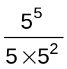. (1 mark)
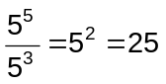

(b) Estimate the solution of 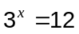 to the nearest whole number. (1 mark)

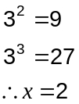

(b) Calculate 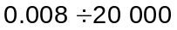, giving your answer in scientific notation. (2 marks)
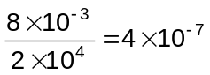

Question 2 (7 marks)
(a) What are the coordinates of the -intercept of the graph of 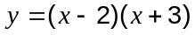? (1 mark)
(0, -6)

(b) How many roots would the graph of 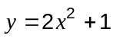 have? (1 mark)
None

(c) What are the coordinates of the turning point of the graph of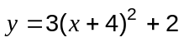? (1 mark)
(-4, 2)

(d) What is the equation of the line of symmetry of the graph of 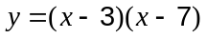? (1 mark)
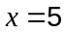

(e) Carefully sketch the graph of 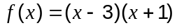 on these axes. (3 marks)
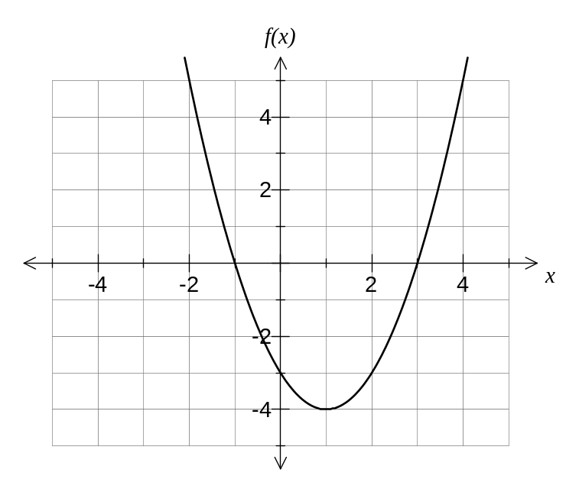

Question 3 (3 marks)
The direct distances in kilometres between a network of six business communication centres in a city are shown in the table below.

 | Centre 1 | Centre 2 | Centre 3 | Centre 4 | Centre 5 | Centre 6
Centre 1 | - | 4 | 7 | - | 2 | 6
Centre 2 | 4 | - | 6 | 3 | 6 | -
Centre 3 | 7 | 6 | - | 7 | - | 7
Centre 4 | - | 3 | 7 | - | 5 | 6
Centre 5 | 2 | 6 | - | 5 | - | 5
Centre 6 | 6 | - | 7 | 6 | 5 | -

Determine the length of the minimal spanning tree for this network.
4+2+6+3+5= 20 km

Question 4 (7 marks)
A group of students sat two tests and their marks are shown on this scatterplot.
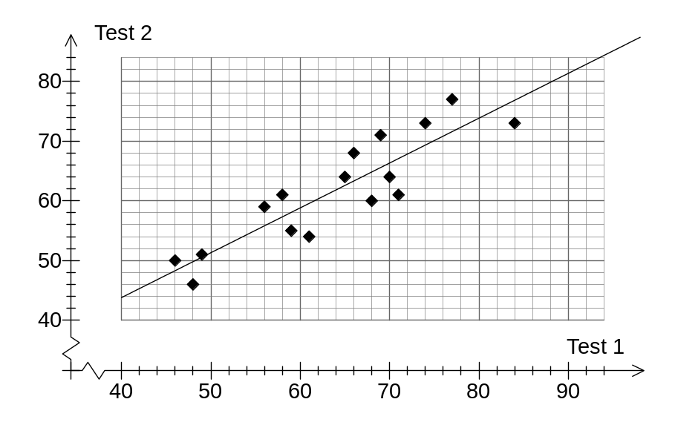

(a) What was the Test 1 mark for the student who scored 68 in Test 2? (1 mark)
66

(b) An A-grade was given to any student scoring over 70 in a test. How many students achieved A-grades in both tests? (1 mark)
3 students

(c) Fit a trend line to the scatterplot. (2 marks)

Li and Sara both missed Test 2, but scored 72 and 90 respectively on Test 1.

(d) Predict the Test 2 marks for Li and Sara. (2 marks)
Li: 68

Sara: 82

(e) Which prediction are you most confident about in part (d)? Explain your answer.
(1 mark)
Li's because the prediction for Sara involves extrapolation which is often risky.
Question 5 (8 marks)
(a) Factorise

(i) 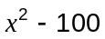 (1 mark)
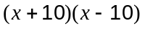

(ii) 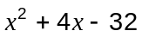 (1 mark)
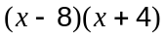

(b) Solve 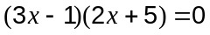 (2 marks)
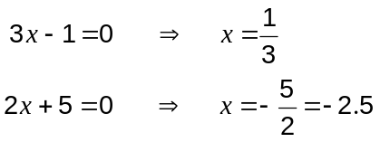

(c) A rectangle has sides of length 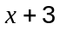 and 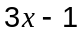 as shown.
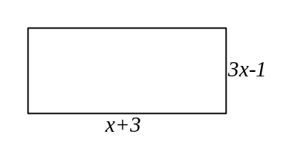
(i) Show that the area of the rectangle is given by 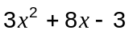. (1 mark)
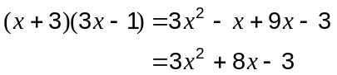

(ii) If the area of the rectangle is also equal to 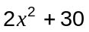, find the value of . (3 marks)
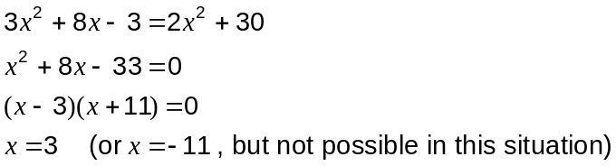
Question 6 (7 marks)
The graph of 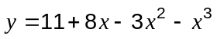 is shown below.
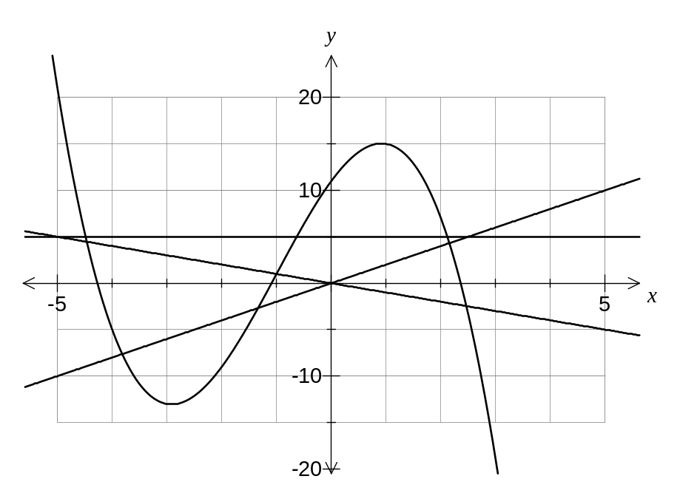

(a) Add the lines 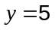, 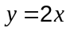 and 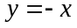 to the axes above. (3 marks)

(b) Estimate the solutions to one decimal place of 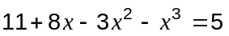. (2 marks)
x = -4.5, -0.6, 2.1

(c) Estimate the solutions to one decimal place of 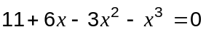. (2 marks)
x = -3.8, -1.3, 2.2

Question 7 (4 marks)
The graph of 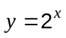 is shown on the axes below.
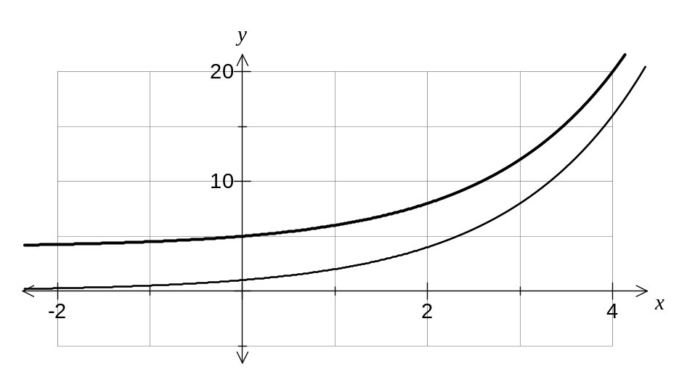

(a) Add the graph of 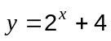 to the above axes. (2 marks)

(b) Describe how the graph of 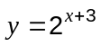 will compare to the original graph of . (1 mark)

The new graph will be a translation of the original graph 3 units to the left.

(c) If the graph of is reflected in the -axis, state the equation of the reflected curve.
(1 mark)
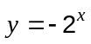

Additional working space

Question number(s):
Additional working space

Question number(s):

